**Architecture**



**Project On:**

**Title: Phishing Domain Detection**

**By: - Dharavath Ramdas**

**(iNeuron.ai)**

**Date: - 12/03/2023**

**Contents**

1. Introduction …………………………………………………. 3

2. Deployment …………………………………………………. 4

**1. Introduction**

**1.1 What is architecture design documents?**

Architectural design of any software shows how is the design of the software. IEEE defines architectural design as “the process of defining a collection of hardware and software components and their interfaces to establish the framework for the development of a computer system.” The software that is built for computer-based systems can exhibit one of these many architectures. Each style will describe a system category that consists of:

* A set of components (e.g.: a database, computational modules) that will perform a function required by the system.
* The set of connectors that will help in coordination, communication, and
* Cooperation between these components.
* Conditions that how components can be integrated to form the system.
* Semantic models help the designer to understand the overall properties of the system.

**1.2 What is Scope?**

Architecture Design Document is an architectural design process that follows a step-by-step refinement process. The process can be used for designing data structures, required software architecture, source code and ultimately, performance algorithms. Overall, the design principles may be defined during requirement analysis and then refined during architectural design work.

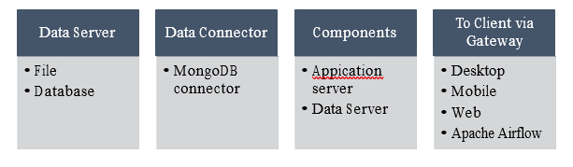

**2. Deployment**

The application is deployed in the azure web server that will take input from the client and it will return the result made by the model into the result section of the webpage.

**WebApp link: https://github.com/dharavathramdas101/Phishing-Domain-Detection-Webapp-Using-ML**